Output: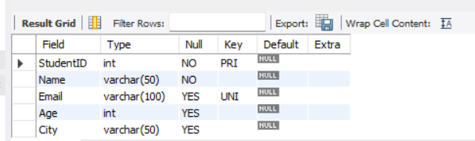

The output shows Student table structure in MySQL with five fields: StudentID, Name, Email, Age, and City, each with its data type defined.
StudentID is the Primary Key, and Email has a Unique constraint to prevent duplicate email addresses.

